Healthy Boxed Lunch or “Bento” Contest

Purpose: A bento lunch is a compact, balanced, visually appealing meal packed in a box. “Bento” is Japanese for packed lunch or meal. Each competitor will create a lunch to be eaten at school by a student age 9 to 12. The beverage to accompany the meal will be water (do not need to include).

Examples found on Pinterest

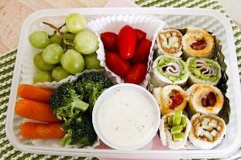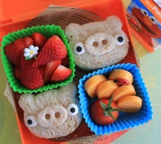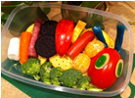

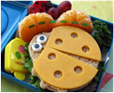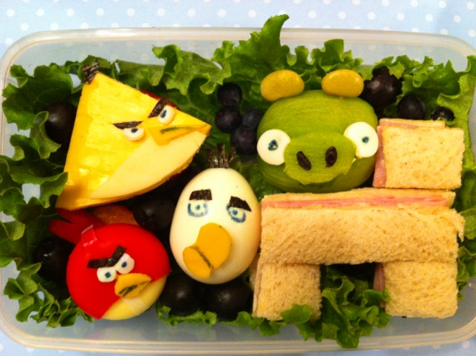

Eligibility: The contestant must be a 4-H club member. Open to any age/grade.
A contestant may enter only ONE entry.

Food Safety: After preparation, the dish must be chilled to 40° F or lower. Dishes must be transported on ice in an ice chest to the contest. DISHES NOT CHILLED AND TRANSPORTED IN THIS MANNER WILL BE DISQUALIFIED BY CONTEST OFFICIALS. Plastic containers, insulated cardboard boxes, etc. are not acceptable containers to transport food (NO EXCEPTIONS). Insulated pharmaceutical and floral boxes, etc are not considered acceptable for transportation of food. Any insulated container not designed to transport food for human consumption will be disqualified. No recipe containing raw eggs will be accepted.

General Requirements:

- Bring a prepared healthy box or Bento lunch to the contest. It should be representative of “MyPlate” recommendations. www.myplate.gov

- Each competitor will create a lunch to be eaten at school by a student age 9 to 12. The beverage to accompany the meal will be water (do not need to include).

- Bring one copy of the recipe/instructions to the contest. This recipe must have your contestant number and dish division – category on the upper right-hand corner. Check with your 4-H agent for your number and other information. The copy of the recipe is to be placed under the dish. Recipes must be printed on 8 ½ X 11” paper. Recipes will be evaluated according to the attached Recipe Evaluation (see general rules). Recipes may be used in publicity and printed in publications. Note: Your recipe will be submitted ahead of time so that it may be evaluated and printed for the cookbook.

- Each competitor will transport their Healthy Box or “Bento” Lunch to the contest packed in a portable, lock-top, and leak proof container, chilled and on ice. The competitor will present the box to the judges for sampling. The food should be exhibited in a disposable serving container, not to exceed 18”. To allow adequate space for all entries. You will be asked to remove items not directly related to the dish, such as placemats, flower arrangements, figurines, trays, footed chafing dishes, soup tureens, etc. Non-edible items are not to be used as garnish. No serving utensils will be allowed.

- Only 4-H members are allowed to set up their dish or someone else’s dish who is not present.

Scoring Factors:
Meal - (100 Points)
Theme – suitable for age group, creative (5 points)
Container – portable, reusable, lock-top, and leak proof (5 points)
Preparation Techniques – neat, interesting, unique (5 points)
Appearance – colorful, inviting (5 points)
Texture - chewiness, juiciness, variety (5 points)
Taste – pleasing, variety (5 points)
Nutrition – (70 points)
Half box is fruits and vegetables
Lean protein included
Low fat dairy included
Fruit for dessert
Portions correct size

Parish Contest:
Each parish can determine how to select a representative for the area event.

Area Contest:
THE DISH MUST BE CHILLED TO 40° F OR LOWER AND TRANSPORTED ON ICE IN AN ICE CHEST TO THE CONTEST.
Last minute preparation should be kept to a minimum as facilities are limited. When last minute preparations are
necessary, agent, parents and teachers should be reminded that this is a 4-H contest and 4-H’ers themselves
should be performing these tasks.

